**Game at:** [**https://www.flippity.net/bg.php?k=147WF5mnKOaYQy6UuzNYsf3vk2EONjFDCFgvM27OvJig**](https://www.flippity.net/bg.php?k=147WF5mnKOaYQy6UuzNYsf3vk2EONjFDCFgvM27OvJig)

**Some vocabulary you might use to talk about the game:**

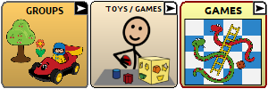

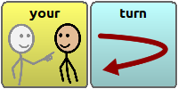



**Numbers for reading dice:** 

**How to find some of the answers to questions:**

**Colours:** 

**Feelings:**  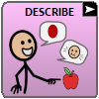

**What’s your favorite……**

**Drinks:** 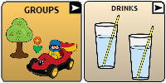

**Food:** 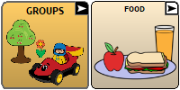

**Dessert:** 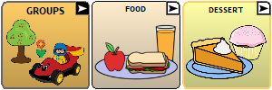

**Sickness or pain:** 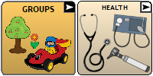

**Hurting - particular body parts:** 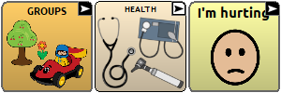

**Places – playground, stores, camping, pool, zoo:** 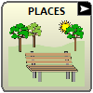

**Specific restaurants:** 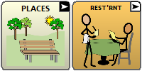

**Social chat - Thank you, good job, how are you?** 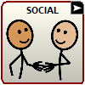

**Pets:** 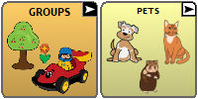

**Animals:** 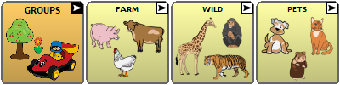

**Holidays:** 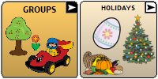

**Personal information - Phone number, birthday, name:** 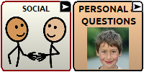

**People:** 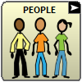 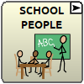

**Classes:** 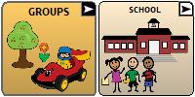

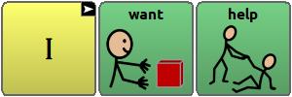

**What did you do last night?**



**Pictures on the board:**

**Orange:** 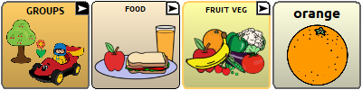

**Planet: 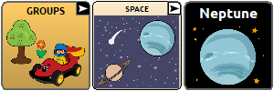 let them choose which planet**

**Wheel:** 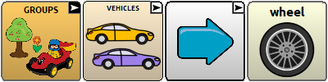

**Candy:** 